PRACTICE 3.1 : INSTALLING HIBERNATE IN ECLIPSE NEON (not Photon or Eclipse1819

IMPORTANT: notes from the teacher:

* Download Eclipse Neon 1.0 for Unit3. Hibernate has problems when you run it in later versions.
* XAMPP MUST BE ON (Apache and MySQL). We need access to the database in some of the steps
* You need Internet connection in some of the steps or they will fail.

INDEX OF THE PRACTICE:

1. Installing hibernate (download it)
2. CONFIGURE MYSQL DRIVER. We have it from Unit 2 (.jar file)

**Window>>Preferences>>Data Management>>Connectivity>>Driver Definitions >>Add**

1. ADD THE DRIVER DEFINITION TO THE PROJECT:

**Build Path>>Add Libraries>>Connectivity Driver Definition (Next)>>>>>Choose "MySQL** **JDBC DriverToEnterprise” (Finish)**

1. STEP 4: CONFIGURE THE FILE ***hibernate.cfg.xml***

**Right-click over the project and choose: New>>Other>>Hibernate>>Hibernate Configuration File (cfg.xml)**

1. NEXT, WE HAVE TO CREATE THE FILE Hibernate Console Configuration:

**New>>Other>>Hibernate>> Console Configuration>>Next**

1. CREATE THE REVERSE ENGENEERING FILE

**New>>Other>>Hibernate>>Hibernate Reverse Engineering File.**

1. GENERATE THE CLASSES MAPPING FROM THE DATABASE:

**Run as>>Hibernate Code Generation Configuration (double click)**

1. CHECK THE CONNECTION TO THE DATABASE WITH HIBERNATE

Open Hibernate Perspective and see tables mapping

REALIZATION:

1. STEP 1: INSTALLING HIBERNATE TOOLS:

OPEN ECLIPSE NEON 1.0. Create a New Java Project “UNIT3-ORM”. Go to Help>>Eclipse MarketPlace. Write "Jboss Tools" in the Find box:

Install the version Jboss Tools 4.4.0 Final

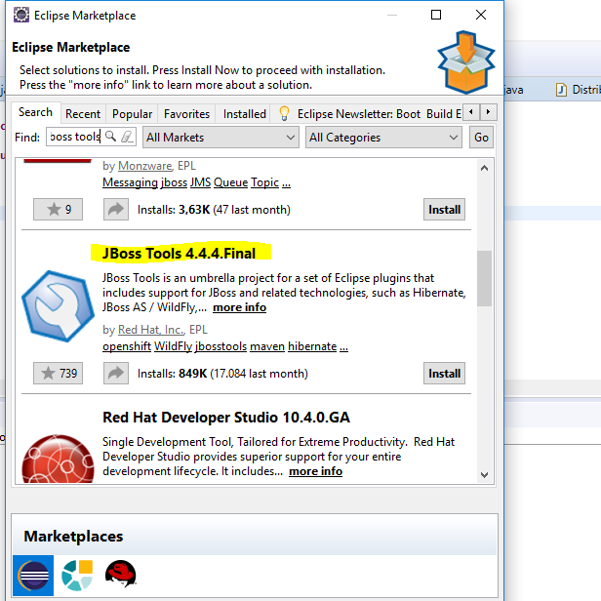

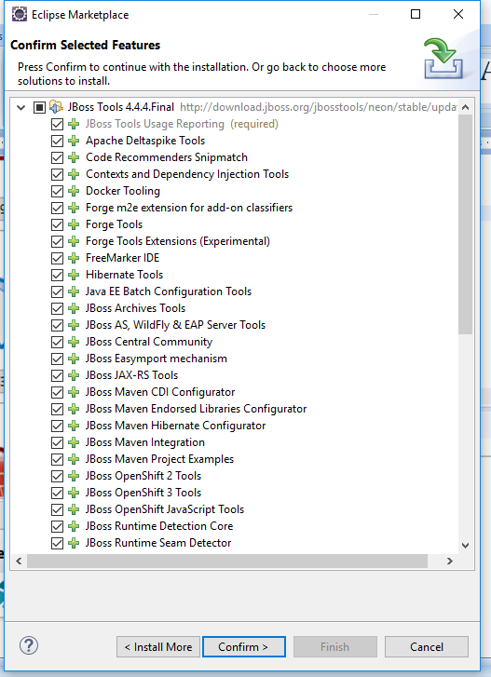

Install all features.

CONFIRM your installation

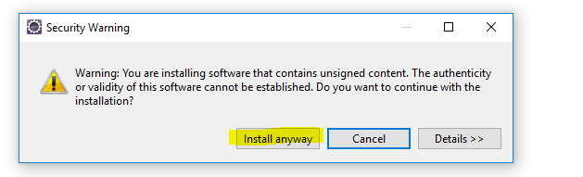

Restart Eclipse to have changes.

Check that Hibernate is installed: Window>>Show View>>Other…

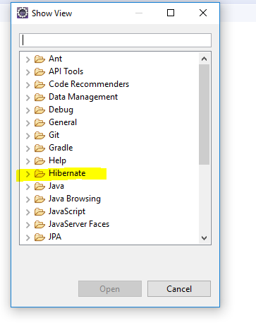

STEP 2: CONFIGURE MYSQL DRIVER. We have it from Unit 2 (.jar file)

Window>>Preferences>>Data Management>>Connectivity>>Driver Definitions >>Add

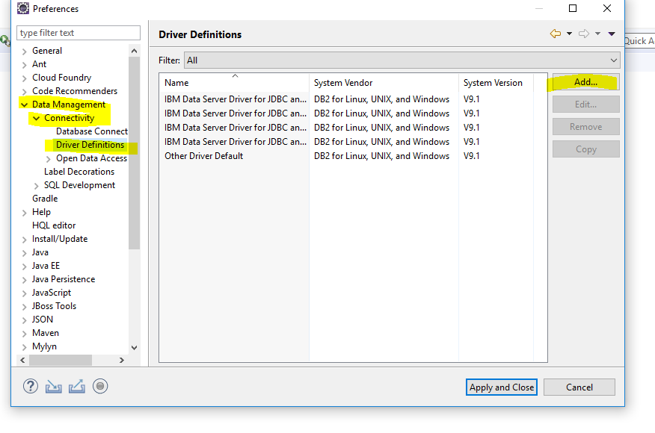

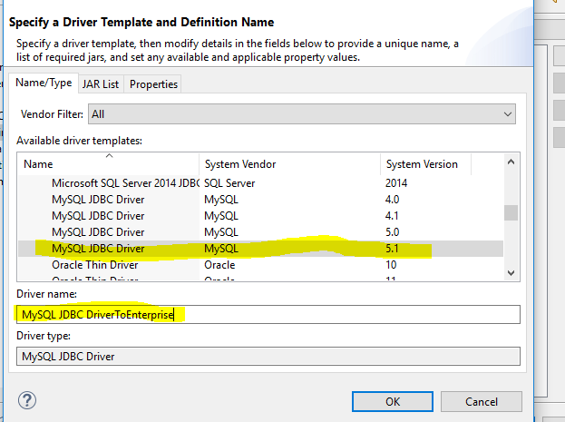

Look at the tab JAR List and Properties and write the correct properties

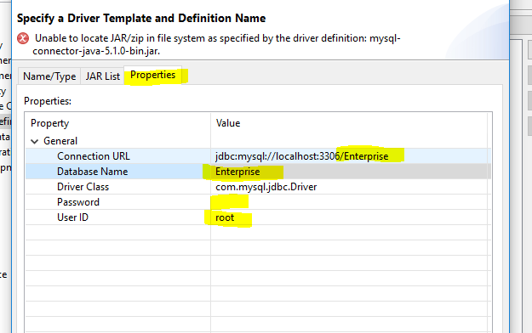

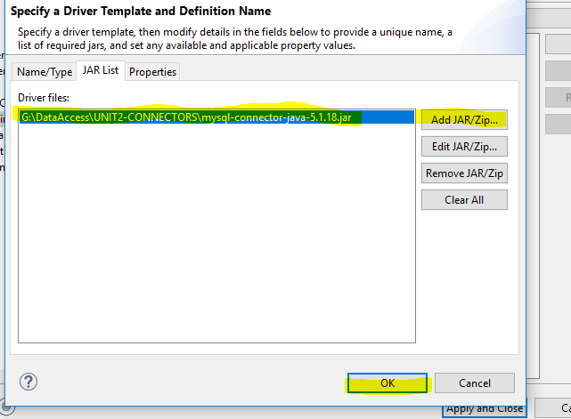

STEP 3: ADD THE DRIVER TO THE PROJECT:

Build Path>>Add Libraries>>Connectivity Driver Definition (Next)>>>>>Choose "MySQL JDBC DriverToEnterprise (Finish)

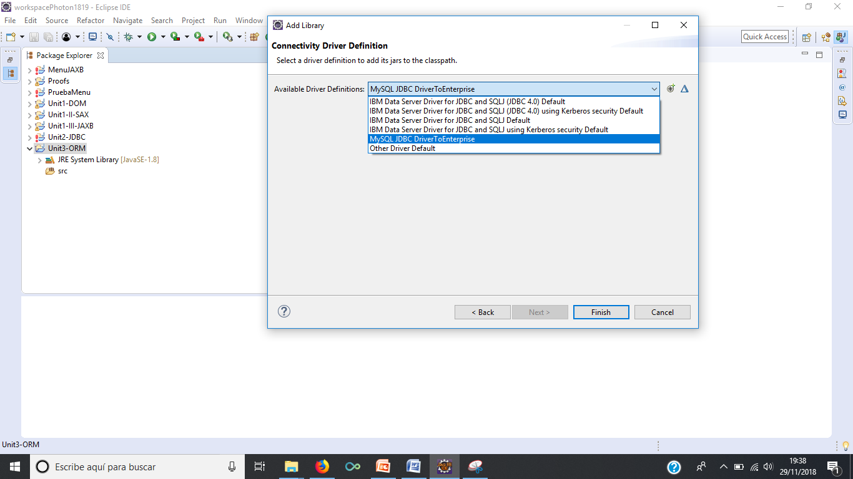

We must have this:

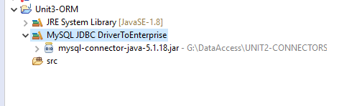

**STEP 4: CONFIGURE THE FILE hibernate.cfg.xml**

Right-click over the project and choose: New>>Other>>Hibernate>>Hibernate Configuration File (cfg.xml)

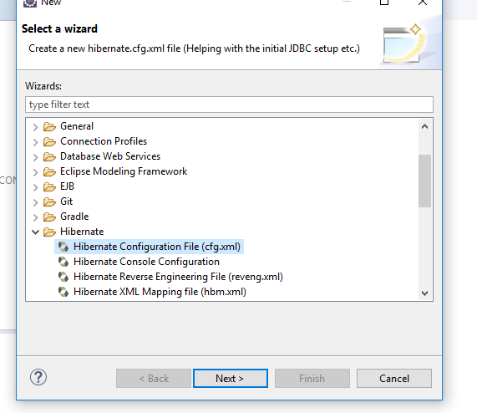

Select src on your project:

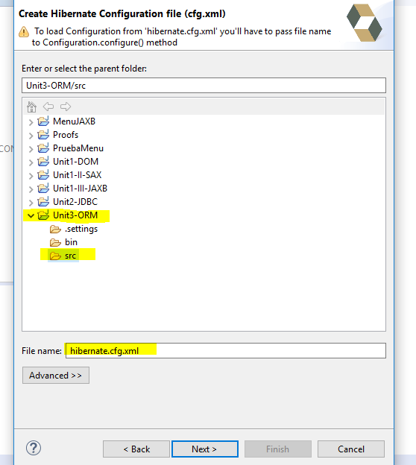

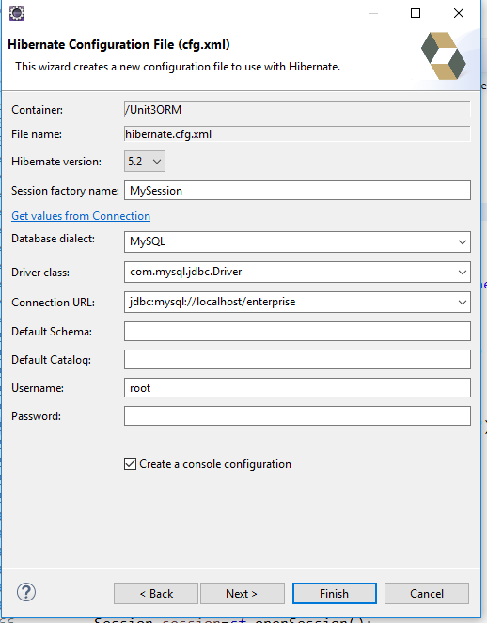

When you finish, you must have the file on the src file: it is an xml file. You can read the code of the file in the tab “source”

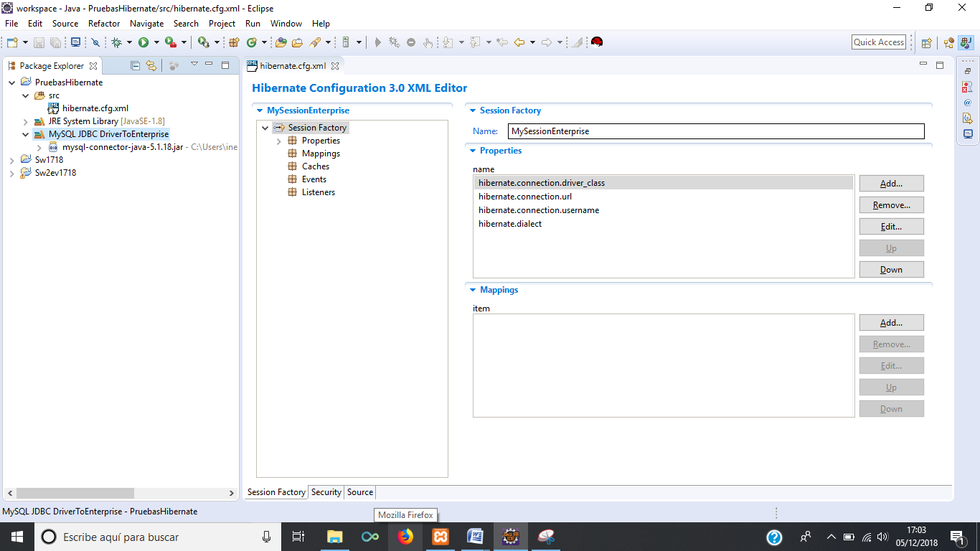

STEP 5: WE HAVE TO CREATE THE FILE Hibernate Console Configuration:

New>>Other>>Hibernate>> Console Configuration>>Next

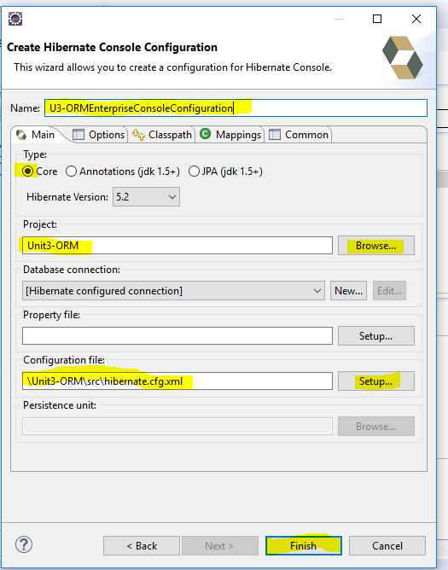

No dice nada, pero se crea la console configuration.

STEP 6. CREATE THE REVERSE ENGENEERING FILE

**New>>Other>>Hibernate>>Hibernate Reverse Engineering File.**

We have to keep the reveng.xml in the same folder than the hibernate.cfg.xml. We have to choose the tables in the database that we want to map with Hibernate. Hibernate will create Java classes related to the tables (similar to JAXB).

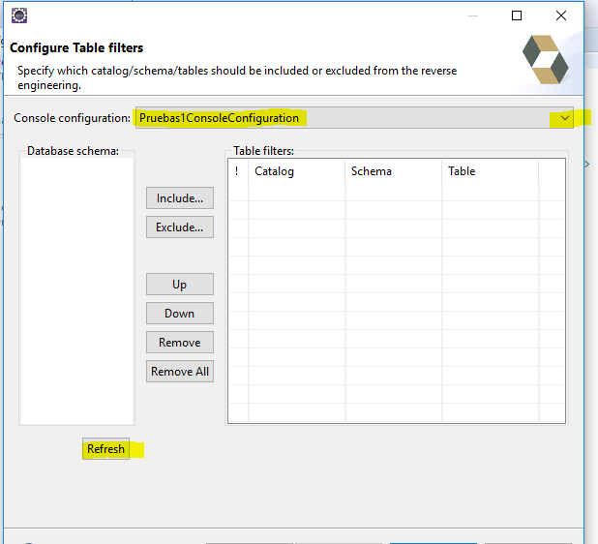

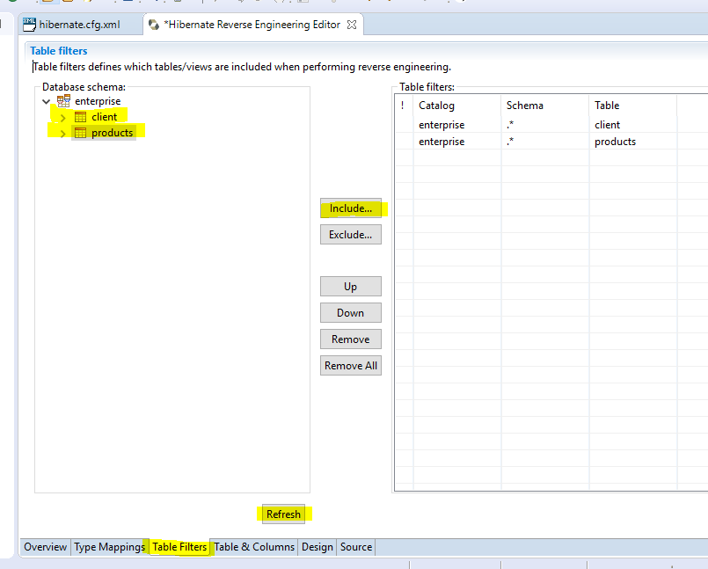

You can view the Reverse Engineering Editor, and see the xml generated in source tab

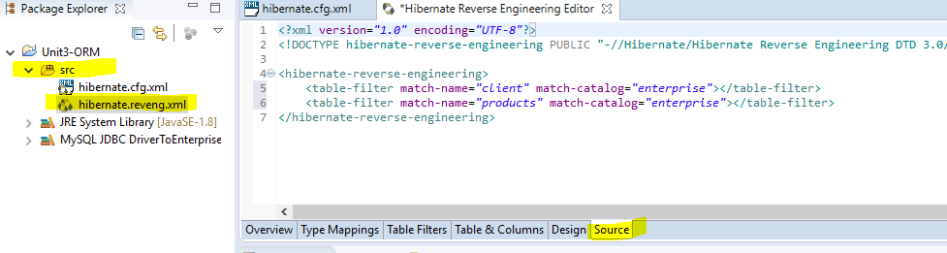

STEP7. CREATE THE CLASSES FOR THE OBJECTS READING FROM THE DATABASE TABLES

Choose the Hibernate View:

Window>>Show View>>Other…>>Hibernate

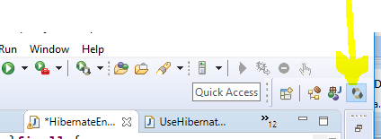

Then select icon RUN AS:

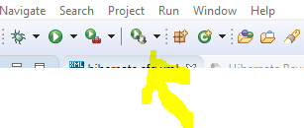

Select **Hibernate Code Generation Configuration…**

Fill tab Main and Exporters:

Write a name for the Code Generation Configuration *ConfigurationORMEnterprise*

Output directory: src folder of out project

Package: write a name you want, where the classes “Clients” and “Products” will be created (MyPackEnterprise)

Reveng.xml: with “Setpup…” browse for the file created in step 6

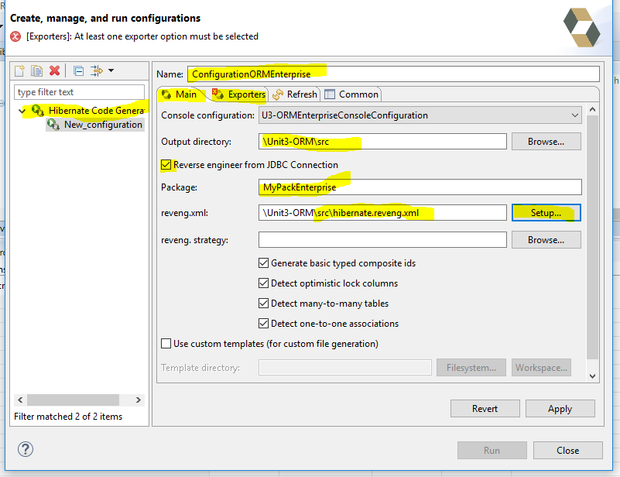

In tab Exporters, say what files we want to create:

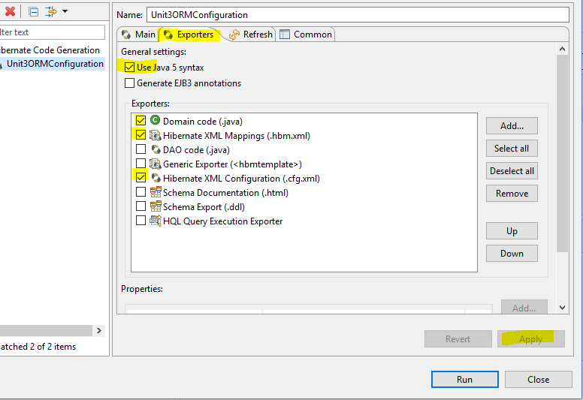

Select Apply and Run (NOTE: WHEN YOU RUN IT, YOU NEED INTERNET CONNECTION, OR IT WILL FAIL).

Check that the classes corresponding to the tables “clients” and “products” have been created:

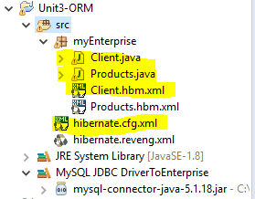

The file hibernate.cfg.xml has added new information now:

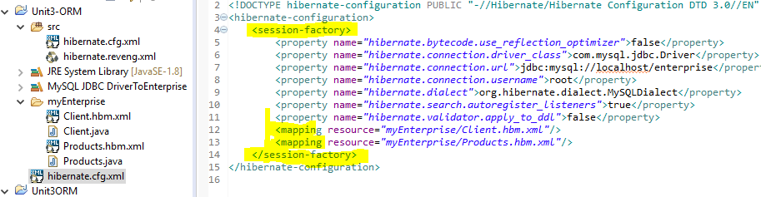

STEP 8: CHECK THAT THE CONNECTION TO THE DATABASE WORKS.

Open Hibernate Perspective: Window>>Perspective>>Open Perspective>>Other>> Hibernate

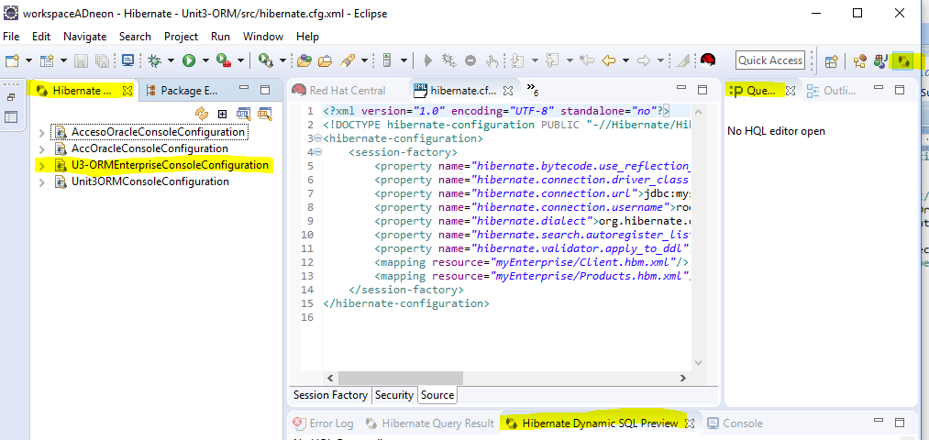

You will see something like that, with your configuration (you must have 1 console configuration; I have 4 because I have done more practices)

Right-click on your Console Configuration and choose “Mapping diagram”: this is the relation between the tables in the database and the classes created by Hibernate. When you work with the classes, you can have the results loaded and saved in the database tables easily (see practice 3.2)

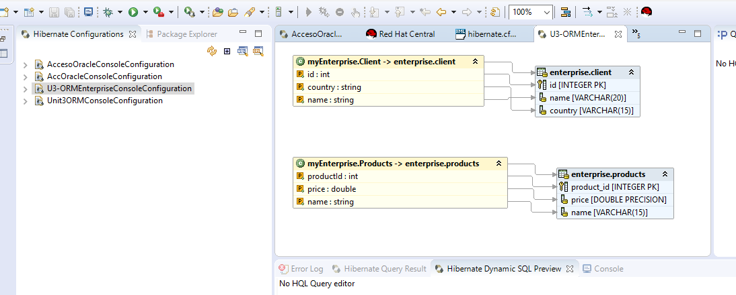

We can do some queries with HQL sentences, but quering the classes (we cannot use *, we have to say the names of the class properties):

* Open the HQL editor: right-click on the Console Configuration, choose “HQL Editor”
* On the window, write the HQL sentence “from Products” and press “RUN”
* 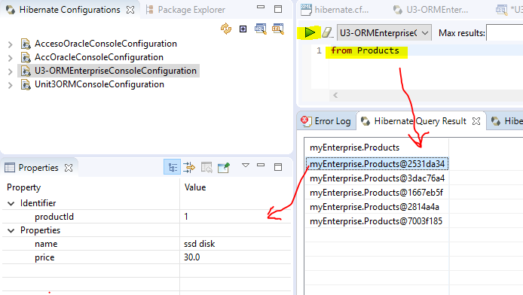

My table PRODUCTS has 5 records, and we see the 5 objects in the Hibernate Query Result

